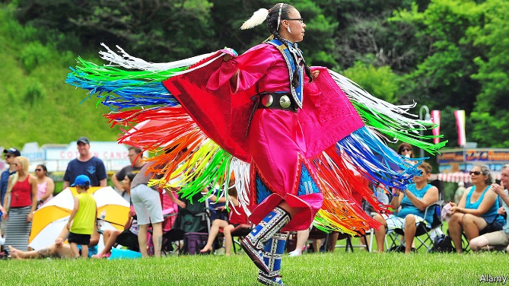Cross-fertilisation or theft?Canada’s war over “cultural appropriation”

Writers on the wrong side of a debate lose their jobs

May 25th 2017 THE ECONOMIST

§1 ANYONE, anywhere “should be encouraged to imagine other peoples, other cultures, other identities”, wrote Hal Niedzviecki in the spring issue of *Write*, an obscure Canadian literary magazine. For that apparently innocuous observation, he lost his job as the publication’s editor. Mr Niedzviecki was defending “cultural appropriation”, the use by artists and writers of motifs and ideas from other cultures. He suggested an “appropriation prize” for creators who carry out such cross-cultural raids. In a special issue of the magazine dedicated to indigenous writers, that was offensive, his critics said.

§2 Mr Niedzviecki’s supporters were also made to suffer. A journalist at the Canadian Broadcasting Corporation was demoted after he offered on Twitter to help finance the prize. The editor of *Walrus*, a better-known magazine, decried “political correctness, tokenism and hypersensitivity” in cultural and academic bodies. After a social-media backlash he, too, resigned. In April a gallery shut an exhibit of the work of Amanda PL, a painter inspired by the style of Norval Morriseau, an indigenous artist.

§3 Mr Niedzviecki has reopened an old debate. Cross-fertilisation is fundamental to the creative process. This article, for example, is written in Roman letters and uses Arabic numerals. However, many indigenous Canadian intellectuals demand extra sensitivity. Some particularly object to white people borrowing (or “stealing”) elements of their culture.

§4 For some, such borrowing evokes memories of centuries of domination by the British and “white settlers”, who took the land of indigenous peoples, tried to force them to assimilate through residential schools and excluded them from mainstream cultural life. Members of indigenous “First Nations” were not allowed to vote until 1960 unless they renounced their Indian status. Robert Jago, an indigenous writer, says that cultural appropriation leads to “the hypersexualised view” of indigenous women, the myth of the drunken Indian and the “football-mascot-inspired stereotype of the violent warrior”.

§5 The argument is now raging on talk shows, in newspapers and especially on social media. Some think it has been inflamed by Donald Trump, who encourages Americans who object to political correctness to say so. “This is the first and probably not the last intrusion” of Trumpian attitudes into Canada’s cultural debate, says Conrad Brunk, co-author of a book on cultural appropriation. Canada’s indigenous peoples, for their part, have also become more assertive. “We’re in a new paradigm” because of social media, says Jesse Wente, an Ojibwe from the Serpent River First Nation, borrowing words from Latin, Greek and English. “We don’t have to occupy chairs in mainstream news media to have our voices heard.”

§6 That is welcome, but the silencing of other voices is not. The hounding of journalists from their jobs chills free speech. Politely, Mr Niedzviecki admits that his defence of cultural appropriation was “a bit tone deaf”. But he should not apologise too much. He provoked a debate on an important and many-sided issue. Canada prides itself on its diversity of peoples. A diversity of ideas matters, too.