Blackface: The Birth of An American Stereotype
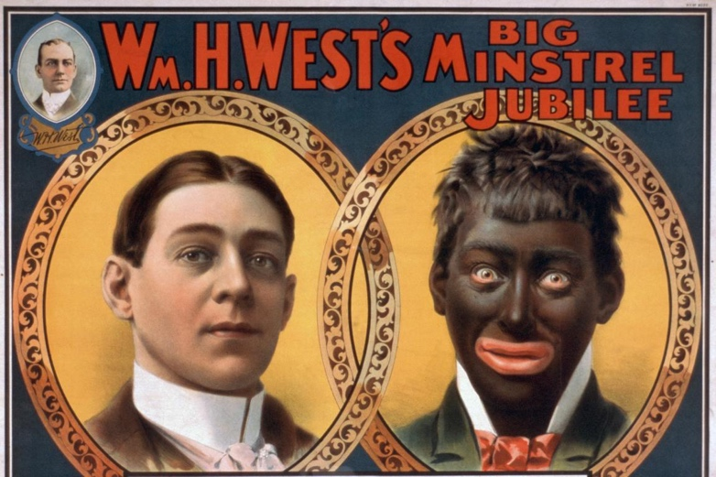
NATIONAL MUSEUM OF AFRICAN-AMERICAN HISTORY
Monday, July 24, 2017

Historian Dale Cockrell once noted that poor and working-class whites who felt “squeezed politically, economically, and socially from the top, but also from the bottom, invented minstrelsy” as a way of expressing the oppression that marked being members of the majority, but outside of the white norm. Minstrelsy, comedic performances of “blackness” by whites in exaggerated costumes and make-up, cannot be separated fully from the racial derision and stereotyping at its core. By distorting the features and culture of African Americans—including their looks, language, dance, deportment, and character—white Americans were able to codify whiteness across class and geopolitical lines as its antithesis.
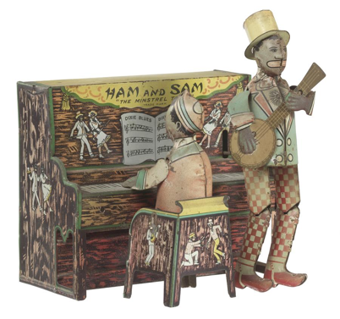

Tin windup toy of "Ham and Sam The Minstrel Team."
The pervasiveness of stereotypical images like these made the civil rights efforts of African Americans even more difficult. The black people represented here were irresponsible, laughable, and difficult to understand. If white people accepted these stereotypes, it became that much easier to deny African Americans the full rights of citizenship.
Collection of the Smithsonian National Museum of African American History and Culture

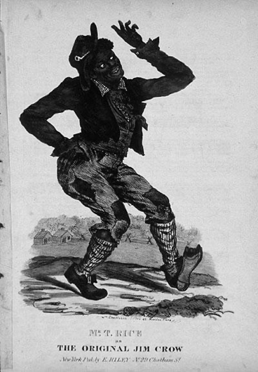

The first minstrel shows were performed in 1830s New York by white performers with blackened faces (most used burnt cork or shoe polish) and tattered clothing who imitated and mimicked enslaved Africans on Southern plantations. These performances characterized blacks as lazy, ignorant, superstitious, hypersexual, and prone to thievery and cowardice. Thomas Dartmouth Rice, known as the “Father of Minstrelsy,” developed the first popularly known blackface character, “Jim Crow” in 1830. By 1845, the popularity of the minstrel had spawned an entertainment subindustry, manufacturing songs and sheet music, makeup, costumes, as well as a ready-set of stereotypes upon which to build new performances.

Blackface performances grew particularly popular between the end of the Civil War and the turn-of-the century in Northern and Midwestern cities, where regular interaction with African Americans was limited. White racial animus grew following Emancipation when antebellum stereotypes collided with actual African Americans and their demands for full citizenship including the right to vote. The influence of minstrelsy and racial stereotyping on American society cannot be overstated. New media ushered minstrel Judy Garland and Mickey Rooney donned blackface, bridging the minstrel performance across generations, and making blackface (racial parody, and stereotypes) a family amusement.

Blackface and the codifying of blackness— language, movement, deportment, and character—as caricature persists through mass media and in public performances today. In addition to the increased popularity of “black” Halloween costumes, colleges and universities across the country continue to battle against student and professor blackface performances. In each instance, those facing scrutiny for blackface performances insist no malice or racial hatred was intended.

